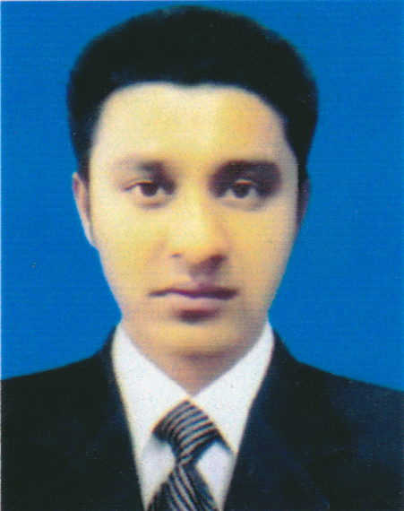
Curriculum Vitae
of
Md. Nazrul Islam
C-51, Koborosthan Lane,
P.O.- Ferozshah-4207,
Akbarshah, Chittagong.
Cell : 01816 242444

Career Objective

To serve in a responsible position at a well-structured organization and successfully apply acquired managerial and interpersonal skills to enhance organizational efficiencies.

Educational Qualification

Diploma in Engineering
Technology – Power & Automobiles
Institution – Chittagong Polytechnic Institute
Board – Bangladesh Technical Education Board
Result – CGPA- 2.90
Passing Year – 2016

Secondary School Certificate (S.S.C- Voc)
Group – Science
Institution – Purba Sandwip High School
Board – Bangladesh Technical Education Board
Result – GPA- 4.81
Passing Year – 2011

Industrial Attachment Training

Successfully completed 03 months Industrial Attachment Training on Power Technology from Aftab Automobiles Ltd., Chittagong.

Experience

Served as a Sub-Asst. Engineer (Power & Automobiles) in Aftab Automobiles Ltd. for 03 years.

Computer Skills

Operating system Windows XP, 7, 10 MS. Word, MS. Excel, MS. Power Point, Website Browsing and Internet using and sound knowledge of all sorts of e-mail correspondence procedure.

Personal Skill :

- Ability to adjust with new environment.
- Ability to undertake multiple task.
- Always want to help others.
- Ability to lead younger.
- Trying to face new challenge.

Interests

Reading Books, Creative Thinking, Watching Movies, Meeting People and Winning Them, Traveling and Playing, Internet Browsing.

Language Competency

Good English and Bengal [Mother Tongue] language proficiency both in oral and written.

Personal Details

Full Name : Md. Nazrul Islam.
Father’s Name : Md. Shahidul Islam.
Mother’s Name : Rahima Begum.
Date of Birth : January 01, 1992
Place of Birth : Chittagong.
Permanent Address : C-51, Koborosthan Lane,
P.O.- Ferozshah-4207,
Akbarshah, Chittagong
Nationality : Bangladeshi.
Religion : Islam.
Sex : Male.
Marital Status : Single.

MD: Nazrul islam
___________________
Signature & Date

